Sprint 2

Wednesday

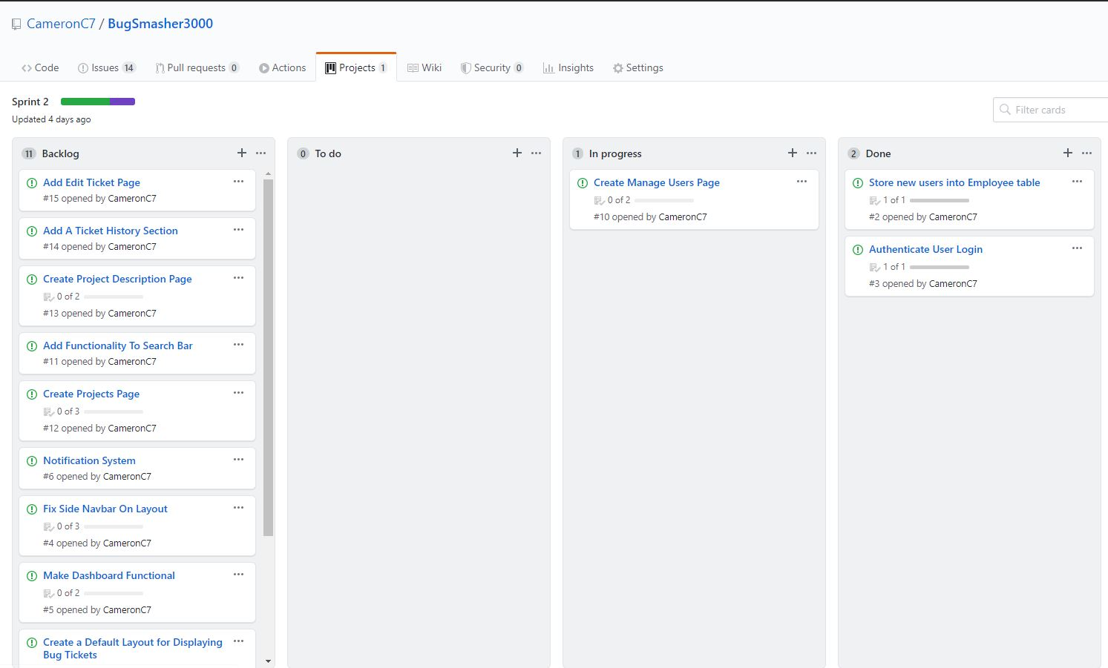

Saturday

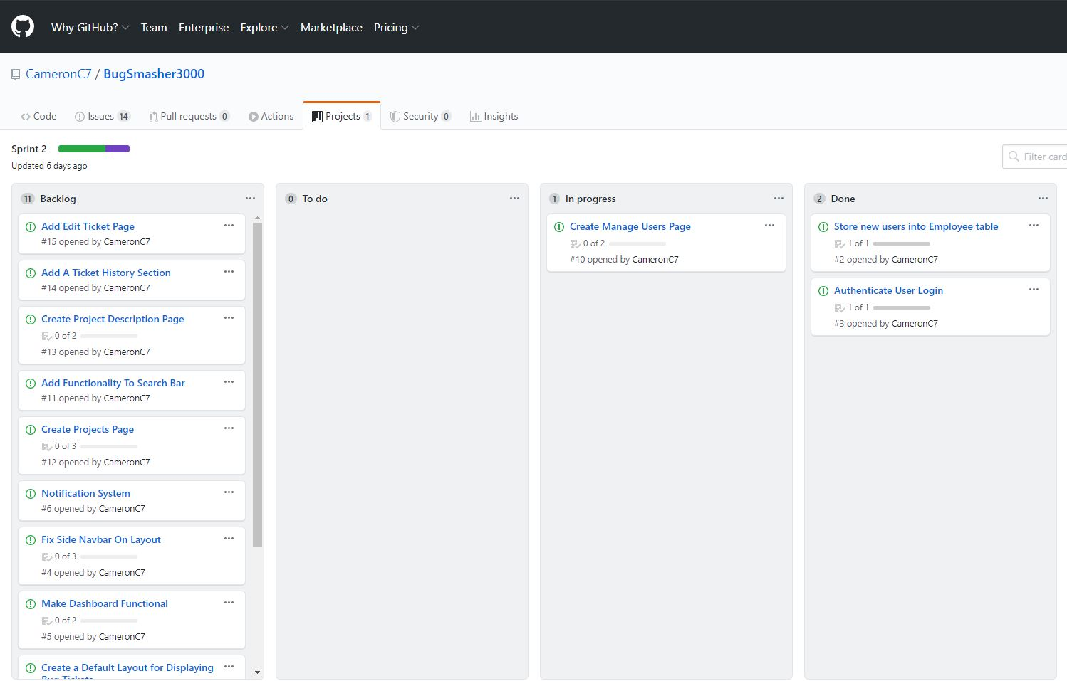

Sprint Review: I was able to complete most of my sprint within the first couple days of the week. The one task I didn’t complete was the Create Manage Users Page, although most of the task is complete. I just needed a little more time to complete the task and my 2nd sprint would have been complete.